Faculty- Sandeep Walvekar

Two most important factors currently
1) Performance
2) Availability

Parallel computing
Distributed computing: e-commerce site ------> backend
|
|---> payment
|
|---> payment gateway
|
|---> front end

Datacenter -> calamity --> data loss
Sol- multiple location datacenter

List to revise for exams:
appengine
ibm democloud ---> putty - execute commands, ex. hadoop commands
|
|--> winscp - load docs to server
codeenvy
RAID prompt$discmgmt msc , vm id and pass- dbda@SKS, dbda@SKS
openMP gcc -fopenmp xyz.c -o new
vm under vm id and pass: root@SKS, root@SKS; adminSKS,passks/passsks

List:
SAAS: https://cloud.google.com/appengine/
PAAS: https://codenvy.com/ , https://www.heroku.com/
IaaS:
https://my.imdemocloud.com/
cloudsigma
VMware
virtual machine, vm under vm
live vm migration
Storage server- window 2000 x86-64
Docker
VMware Esxi software
RAID
OpenMP

TCP/IP: suit of protocols
IP addressing: IpV4 32 bit
|__| |__| |__| |__| 4 octets
192.168.10.1 postal code
/ \ /\
/ \ 411 039
network address host addresses city area

SUBNET MASK:

Make all network bits 1, host bits 0
Network bits and Host bits are decided by subnet mask.

Class
|______| |______| |______| |______|
A- 1 -127
B- 128-191 Ex. 172. . .
C- 192-223 Ex. 192.167. .
D- 224-239 Multicast
E- 240 onwards Reserved for future experimental purpose

Only A-C used for computer addressing (direct addressing)

Class SubnetMask
A 1 -127 255.0.0.
B 128-191 255.255.0.0
C 192-223 255.255.255.0

Private Ip Vs Public Ip
Private Ip is not usesd in Internet, public Ip is used

Just as your network's public IP address is issued by your ISP, your router issues private (or internal) IPaddresses to each network device inside your network. This provides unique identification for devices that are within your home network, such as your computer, your Slingbox, and so on.

Internet ←---- Network address translation ←---- Network
196.1.113.13 192.168.76.2,192.168.75.4..so on

Dynamic Ip and Static Ip/Fixed Ip
Difference between static and dynamic IPs. When a device is assigned a static IPaddress, the address does not change. Most devices use dynamic IP ddresses, which are assigned by the network when they connect and change over time

Exercise:
192.128.1.45/28
First 8 bits for network addresses. Therefore, 4 bits remaining for host. 2^4 = 16.

192.168.1.0 - 192.168.1.15
192.168.1.16 - 31
192.168.1.32 – 47

0.0.0.0 → all host bits zero (network address)
1.1.1.1 → all host bits 1(broadcast)

Exercse-2
192.168.1.78
subnet: 255.255.255.224
|__| |__| |__| 11011111
←------subnet-------→ first 3 bits in last octet- 128+64+32 = 224

00000 -network address
|
| 30 network addresses
|
11111 broad cast address

Sir way:
256-224 = 32
32 – (network address) – (broadcast address)
=30

Exercise 3:
172.16.56.35

255.255.240.0 (/20)
11111111.11111111.11110000.
←-----mask----------→
172. 16 .56 .0
0011 1000
<-48->

TCP and UDP
TCP- connection oriented
UDP- connection less

Client Server
-----syn----→
←-syn+ack-----
-----ack-----→
----http get-→
←---ack--------

TCP UDP
reliable Unreliable
Flow control No flow control
slow Fast

UDP doesn’t take care of lost data. It’s the application (user) who needs to take care of it.

TCP
http 80
https 443
ssh 22
telne t 23
ftp 20,21
smtp 25

Domain name System:
com edu org in/co bil

Name and Ip resolution:
suyog@sks-Inspiron-15-3567:~$ cat /etc/hosts
127.0.0.1 localhost
127.0.1.1 sks-Inspiron-15-3567

A DNS cache (sometimes called a DNS resolver cache) is a temporary database, maintained by a computer's operating system, that contains records of all the recent visits and attempted visits to websites and other internet domains.

SAAS PAAS IAAS

Cloud services can be a very nebulous concept even before throwing in acronyms that stand for Infrastructure-as-a-Service, Platform-as-a-Service, and Software-as-a-Service. The three options describe the tasks and responsibilities of the service provider in relation to those of users.

IaaS gives users automated and scalable environments with extreme flexibility and control, while PaaS provides a framework for quickly developing and deploying applications by automating infrastructure provisioning and management. Eliminating the need to install and run programs on individual devices, SaaS makes applications available through the internet.

IaaS, PaaS and SaaS are cloud computing service models.

IaaS (Infrastructure as a Service), as the name suggests, provides you the computing infrastructure, physical or (quite often) virtual machines and other resources like virtual-machine disk image library, block and file-based storage, firewalls, load balancers, IP addresses, virtual local area networks etc.
Examples: Amazon EC2, Windows Azure, Rackspace, Google Compute Engine.

PaaS (Platform as a Service), as the name suggests, provides you computing platforms which typically includes operating system, programming language execution environment, database, web server etc.
Examples: AWS Elastic Beanstalk, Windows Azure, Heroku, Force.com, Google App Engine, Apache Stratos.

While in SaaS (Software as a Service) model you are provided with access to application software often referred to as "on-demand software". You don't have to worry about the installation, setup and running of the application. Service provider will do that for you. You just have to pay and use it through some client.

Examples: Google Apps, Microsoft Office 365.

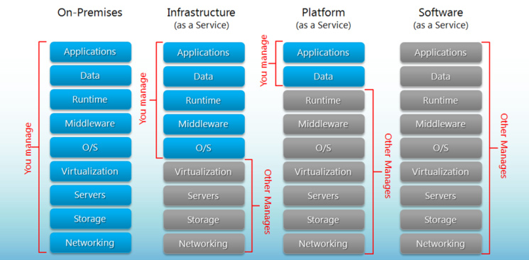

SaaS- Software as a service
https://cloud.google.com/appengine/
https://cloud.google.com/appengine/docs/
https://cloud.google.com/appengine/downloads
download and install GoogleAppEngine-1.9.50
account- ssethia86@gmail.com through google
install python 2.7.13
Note: If you get access error or similar error, then create app in dbda folder/domain.
Open app engine --> create new app --> pick parent directory (C:\Users\dbda\Documents\parent dir appengine) ----> open it --> edit main.py --> self.response.write('Hello! engineappsks ran')
https://cloud.google.com/appengine/docs/ --> login --> console --> create project --> same name as app --> appengine menu in left hand side -> compute (left column menu) --> appengine --> settings language --> python
Application name: engineappsks

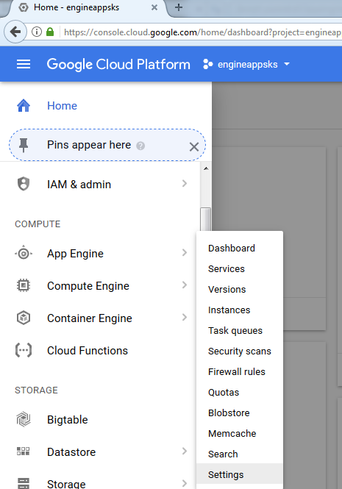

projectid.appspot.com

Running two versions of same app
Tasks: Upload two versions of same app
Create project --> create app --> "This is version 1"
Next -> "This is updated version 1"
Edit --> app.yaml --> version 2 --> "This is version 2"

Edit app.yaml (in parent directory) --> change "version: 1" to "version: 2" --> edit "main.py" , put some text if needed --> deploy
compute --> appengine --> versopms --> We can see two app running
appengine --> versions
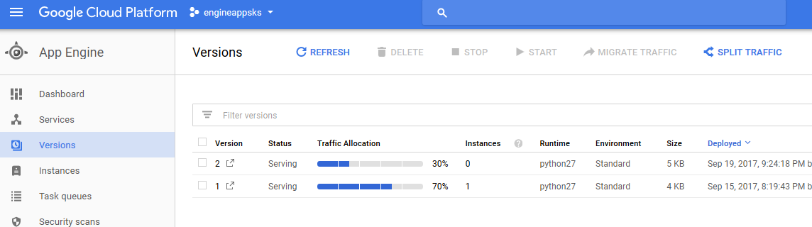

split traffic -> can split traffic between two versions
appengine --> quotas
appengine --> service
migration --> click on other version --> migrate

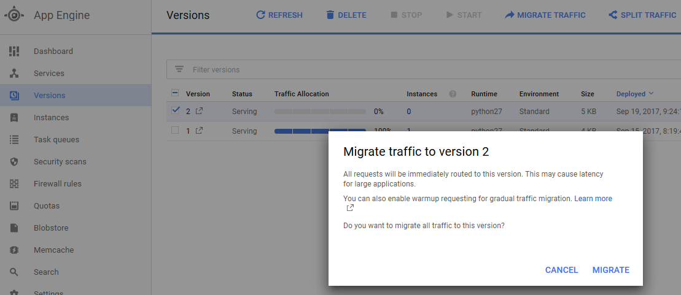
appengine --> firewall rules --> to block ip address of any miscreant
appengine --> settings --> custom domain

PaaS- platform as a service

https://codenvy.com/
account- ssethia86@gmail.com through google
create workspace --> name- "java" --> single machine --> create
create new project --> java (ex, name "hello")--> tab at left --> hello --> src --> Main.java
src --> right click --> java class --> hello.java --> dev machine -->
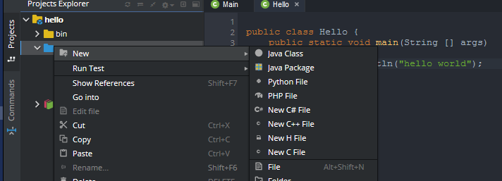

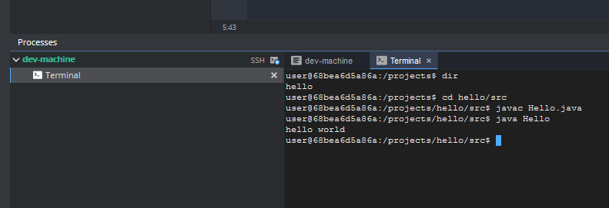
projects$ cd hello/src
projects$ java Hello.java
projects$ java Hello

Tip:
PAAS (create app on it) --> SAAS (upload app on it) --> income

heroku (PaaS)
https://www.heroku.com/
Heroku is a platform as a service (PaaS) that enables developers to build, run, and operate applications entirely in the cloud

Hyperviser
A hypervisor or virtual machine monitor (VMM) is computer software, firmware or hardware that creates and runs virtual machines. A computer on which a hypervisor runs one or more virtual machines is called a host machine, and each virtual machine is called a guest machine.
Software that provides virtualization is hypervisor.

A bare metal environment is a computer system or network in which a virtual machine is installed directly on hardware rather than within the host operating system (OS). The term "bare metal" refers to a hard disk, the usual medium on which a computer's OS is installed.

IAAS – cloudsigma, MS Azure
https://zrh.cloudsigma.com/ui/

create machine → open vnc → desktop

PuTTy needed?
PAAS- HEROKU
https://www.heroku.com/
worer$265DFD@1
qwss86gml&syg@HRKU#1133

language → Java

https://git-scm.com/
https://maven.apache.org/docs/3.3.9/release-notes.html

check this
(Window OS)MYComputer → properties → advanced system setting → env variables(git bin) → path ------edit--→ C:/apache_maven.3.3.9

environment variables: export PATH = $PATH;C:\..

maven → maven cmdline interface → heroku login → give credentials → github url download code → gitclone steps → heroku create app.yaml

download cli → cmdline → heroku → credentials → click “I have done”

git remote -v
git remote rm heroku
git push heroku master

VMware

Creating virtual machine on Vmware or Oracle Virtual Box
Sample- 2 core, HD 40 GB, memory 2 GB

Configuring Virtualization on Single Linux Machine
Create a Virtual Machine in VMware or Oracle Virtual Box. [guide is provided in material]

ctrl + alt to restore original cursor/pointer/mouse

VM 1 name: sksVM1_RHEL 6 64 bit
Path to directory where this virtual machine files will be stored: C:\Users\dbda\Documents\Virtual Machines\sksVM1_RHEL 6 64 bit
disk file: sksVM1_RHEL 6 64 bit.vmdk
rootpass- dbda2017

In class: we made VM with 6 GB RAM, 2 processors
username: admin
password: password

local host QEMU- newVM1

error: After checking "connected", a window with list of folder opens. Which files to choose?
solved- given generic , state name of os and version

Live Virtual Machine migration:

virtual server 1- local host
virtual server 2- remote host
3 separate vm in virtual machine

STORAGE SERVER

Migrating VM from one storage server to another

PASSWORDLESS SSH
ssh -keygen -t rsa
..enter, enter, enter
ls .ssh
ssh copy-id -i .ssh/id_rsa.pub root@

IBM Analytics Demo Cloud:

Demo Cloud provides you with environments you can use to explore and experiment with new software capabilities.

https://my.imdemocloud.com/
account- ssethia86@gmail.com, $$$syg@CLOUD#11.22.33%IBM

Install:
PuTTy- remote
Winscp- remote copying tool

Once done, log in PuTTy:
$hdfs dfs -ls /
$hdfs dfs -mkdir test1

Big SQL Sandbox
Big SQL Sandbox is a large, shared environment for data science. You can use it to run R, SQL, Spark, and Hadoop jobs. It is a high performance cluster demonstrating the advantages of parallelized processing of big data sets.

Connection Details
Your username is ssethia86. All services use your Demo Cloud password. Change the password in your profile .
The server hostname is systemt.datascientistworkbench.com
You can use your Demo Cloud username and password to connect to the SSH command line on the cluster. Sample command:
ssh ssethia86@systemt.datascientistworkbench.com

PuTTY- putty-64bit-0.70-installer
Install PuTTY --> Open PuTTY --> host name- systemt.datascientistworkbench.com
login as: username is ssethia86. passwd: diya to hai

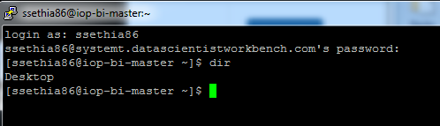
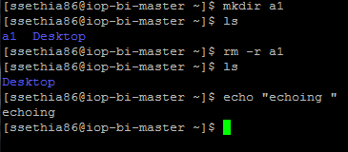
It opened Linux machine
create machine --> open VNC (virtual network computing) --> PuTTY? --> Desktop
guest: no access to root (sudo is available)

To copy data we have to use Winscp:
open Winscp → paste host name again

By using Winscp→ copy data into server
By using PuTTy- execute commands

OPENSTACK
OpenStack is a free and open-source software platform for cloud computing, mostly deployed as infrastructure-as-a-service, whereby virtual servers and other resources are made available to customers

NASA also use it for some of its projects.

Comparing Containers and Virtual Machines

Containers and virtual machines have similar resource isolation and allocation benefits, but function differently because containers virtualize the operating system instead of hardware. Containers are more portable and efficient.

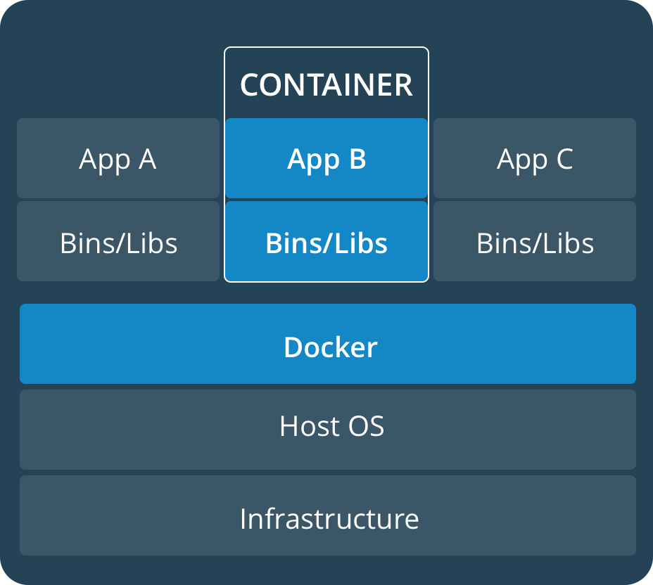
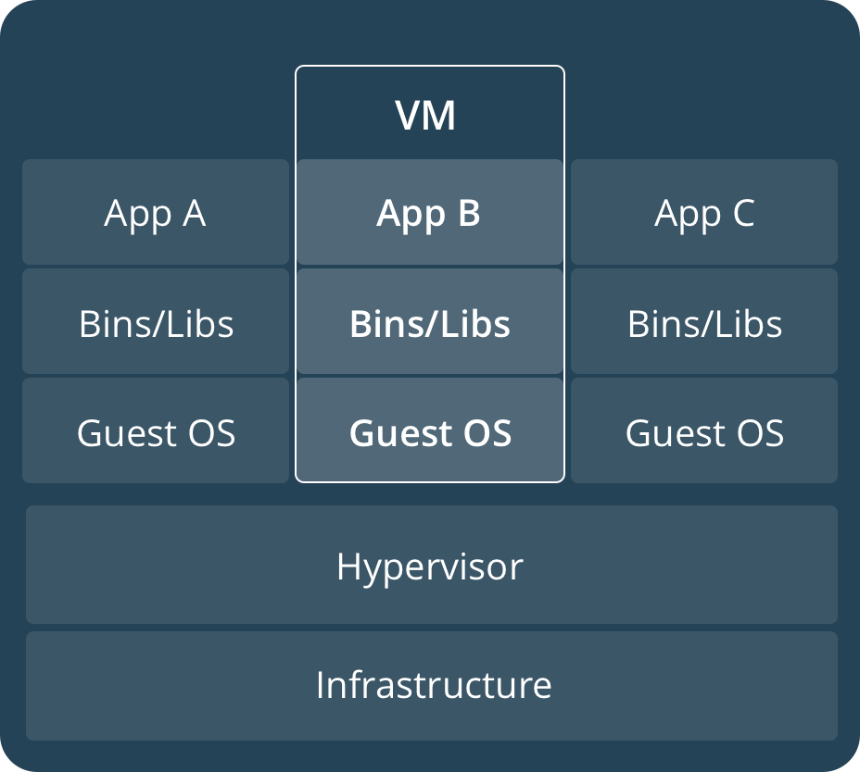

CONTAINERS
Containers are an abstraction at the app layer that packages code and dependencies together. Multiple containers can run on the same machine and share the OS kernel with other containers, each running as isolated processes in user space. Containers take up less space than VMs (container images are typically tens of MBs in size), and start almost instantly.

VIRTUAL MACHINES
Virtual machines (VMs) are an abstraction of physical hardware turning one server into many servers. The hypervisor allows multiple VMs to run on a single machine. Each VM includes a full copy of an operating system, one or more apps, necessary binaries and libraries - taking up tens of GBs. VMs can also be slow to boot.

DOCKER
https://hub.docker.com/

Docker:
Its a container. Docker preferred over virtualization
we use community edition

In vmware vm:
# sudo service docker start
# sudo docker ps -q
# docker images
to test installation:
# sudo docker run hello-world
# docker run ubuntu
WARNING: Error loading config file: /home/suyog/.docker/config.json - stat /home/suyog/.docker/config.json: permission denied
Unable to find image 'ubuntu:latest' locally
latest: Pulling from library/ubuntu
50aff78429b1: Pull complete
f6d82e297bce: Pull complete
275abb2c8a6f: Pull complete
9f15a39356d6: Pull complete
fc0342a94c89: Pull complete
Digest: sha256:ec0e4e8bf2c1178e025099eed57c566959bb408c6b478c284c1683bc4298b683
Status: Downloaded newer image for ubuntu:latest

#docker run -i -t ubuntu /bin/bash
#ls
#mkdir /docker

From another terminal (it wont work from docker terminal):
#docker ps

docker terminal:
#exit

For testing we can give applications to people

1. sudo yum-config-manager --add-repo
https://download.docker.com/linux/centos/docker-ce.repo

2. sudo yum makecache fast

3. sudo yum install docker-ce

4. sudo systemctl start docker

5. sudo docker run hello-world
(This is to test docker installation)

Misc
https://finance.google.com/finance
https://developers.facebook.com/
Amazon web services (AWS)?

HIGH PERFORMANCE COMPUTING

Most important – Processor
Dynamic RAM- 1 transistor 1 capacitor
Static RAM – 6 transistor 1 capacitor

capacitor tend to loose charge, so need to refresh in dynamic RAM
Hence, static is faster. Cycle is not wasted in refreshing.

Process---|-- CISC complex instruction set computing
|-- Reduced instruction set computing

CISC- built in instructions
smaller applications- RISC faster
larger apps- CISC faster

Mobile -RISC
Desktop- CISC

Recall we checked “vte something box” during virtualization, so it wrote built in instruction.

GP-GPU: general purpose graphical processing units

Blade server Vs server

THREAD and PROCESS
Thread- program in execution. It is light weight processes
PCB- process control block

Process P1 (only 1 PCB is created) → threads t1,t2 and t3 → context witch is required but less time taken

.dll can be saved as .exe, but why not? .dll dont start new process, less overhead

Race condition- ATM case. Machine didn’t dispensed cash, but account got debited.

Concurrence: T1 withraws 3000 from 10k, T2 (unaware) withdraws 1000 from 10k. Net balance = 9000. T1 and T2 are threads.

Deadlock: A and B Both needs R1 and R2. A has R1, B has R2.

Asymmetric and Symmetric multiprocessing (SMP and ASMP):
In SMP processors are at same level, any processor can take any job. In ASMP, slave processor will need direction from master.

RAID- REDUNDANT ARRAY OF INDEPENDEDNT DISK

RAID0 → 1
RAID2 → ----|--→ mirroring
|--→
faster read

RAID5 → ---|---→ [2, 2, 10]
| parity
|---→ [3, 8, 2]
| parity
|---→ [6, 4, 5]
parity
Parity to rebuild data or recover.
Lets say we have multiplication of 2 and 3 = 6 (parity)
Similary, 5 x 2 =10 (parity), and 2 x 4 =8(parity)

If two disks fail, then data is lost.

RAID6 → 2 parity

OPENMP

Basically for C and C++

$gcc -fopenmp
suyog@sks-Inspiron-15-3567:~$ vi firstOpenmp.c
#include <stdio.h>
#include <omp.h>
int main()
{
int ID = 0;
#pragma omp parallel num_threads(2)
{
printf(" hello(%d) ", ID);
printf(" world(%d) \n", ID);
}
}
suyog@sks-Inspiron-15-3567:~$ gcc -fopenmp firstOpenmp.c -o executableOpenmp
suyog@sks-Inspiron-15-3567:~$ ls
derby.log executableOpenmp jdk-8u151-linux-x64.tar.gz
suyog@sks-Inspiron-15-3567:~$ ./executableOpenmp
hello(0) world(0)
hello(0) world(0)

$vi first.c
changing ID=0 to ID=omp_get_thread_num();

suyog@sks-Inspiron-15-3567:~$ gcc -fopenmp firstOpenmp.c -o executableOpenmp
suyog@sks-Inspiron-15-3567:~$ ./executableOpenmp
whichever thread get ready first will start executing. So, random sequence.

End

